ARCHIVES OF THE CATHOLIC ARCHDIOCESE OF PERTH

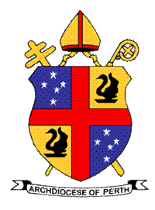

FAMILY HISTORY RESEARCH REQUEST

The staff of the Archives of the Catholic Archdiocese of Perth (the Archives) have a responsibility to prioritise management of the records of the Archdiocese in accordance with archival best practice and in a manner that supports the work of the Archbishop.

The Archives would appreciate a donation as the service is not otherwise funded.

- Ancestor’s Details

Ancestor’s Full Name (Include alternative spellings
Ancestor’s Date of Birth
or approximate year
Ancestor’s place of birth/Baptism, locality or Parish
Father’s Name
Mother’s Name
Additional Information (if available)

- Inquirer’s details

Postal Address |  |  | Work Phone
 |  |  | Mobile
 |  |  | Email
Reason for the request

- Office Use only – Search Result

Search Result

