Date of Application:
- Ancestor’s Details

Ancestor’s Full Name (Include alternative spellings)
Ancestor’s Date of Birth
or approximate year
Ancestor’s place of birth/Baptism, locality or Parish
Father’s Name
Mother’s Name
Additional Information (if available)
- Applicant Details

Surname |  |  | First Name
Postal Address |  |  | Work Phone
 |  |  | Mobile
 |  |  | Email
Reason for the request

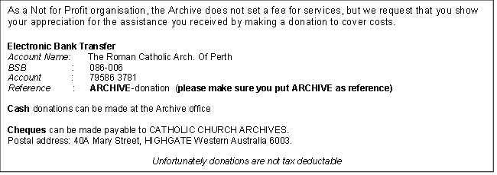

- Office Use only – Search Result

Search Result

We hope we were able to assist you.

