CATHOLIC ARCHDIOCESE OF PERTH

CATHOLIC ARCHDIOCESE OF PERTH

CHILD MIGRANT REQUEST

Archives and Information Governance Office

I request copies of documents relating to my time as a Child Migrant now held by the Archives of the Roman Catholic Archdiocese of Perth.

CHRISTIAN NAME:
SURNAME:
DATE OF BIRTH:
NAME OF INSTITUTION:
I HAVE ENCLOSED A COPY OF MY FOLLOWING AS PROOF OF IDENTITY: (PASSPORT, LICENSE, ETC,)

Signed:

Date:

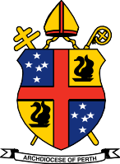
Address:
193 Harold St, Mt Lawley, WA 6050
Mailing Address:
40A Mary St, Highgate, WA 6003
Telephone:
+61 8 6104 3626
Email: archives@perthcatholic.org.au
Website: www.perthcatholic.org.au

